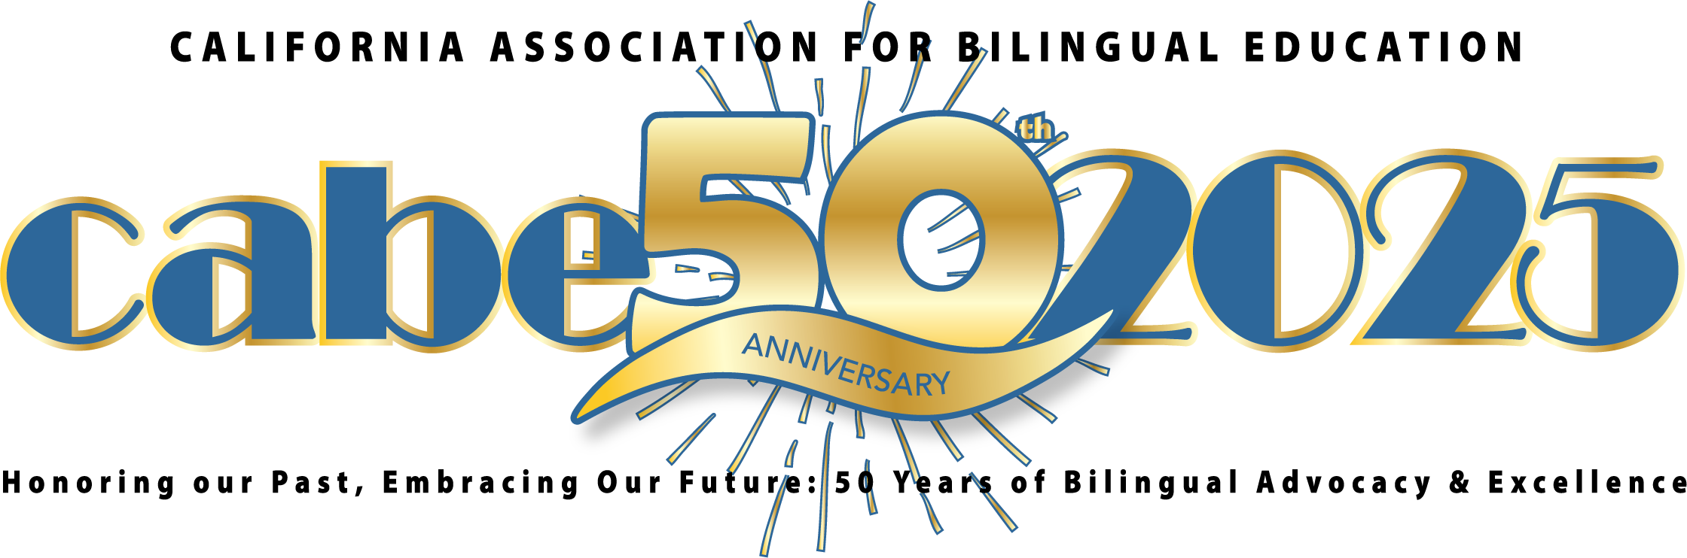

CABE 2025 Seal of Excellence School Award Guidelines

**Online Application Submission Requirements**

(Please carefully read the following before completing and submitting the nomination application. Note: The nominator must be either the principal of the school or a district administrator. The principal will be the main point of contact throughout the process.)

**Public, charter, and private schools are eligible to apply, inclusive of all types of school configurations (i.e. TK-5, 6-8, 9-12). Elementary schools must have a program that has an established five-year pathway. Middle and junior high schools must have an established pathway between the feeder schools (elementary and/or high school).**

Upon receipt of a completed online nomination application that includes a description of the evidence from each of the criteria found below, each school submission will be assessed through the lens of CABE’s vision and mission, the principles and elements found in the Guiding Principles for Dual Language Education, 3rd edition, the California English Learner Roadmap, the California ELA/ELD Framework, and current research and findings in the field of dual language education. The online nomination application must include the following:

* Concise and clear narrative responses including strong qualitative and quantitative evidence that highlights the school’s strengths and accomplishments, focusing on what makes the school exemplary for multilingual and English learner students.
* A two-minute video highlighting the community, the school’s program, the teachers, the students in the classroom, and any other features that make the program exemplary. (Note: CABE reserves the right to edit and share the video of any school that is awarded the Seal of Excellence School Award.)
* Five high-resolution (300 dpi or greater) photos (jpeg, png, tiff) depicting highlights of the program.
* Additional supporting documents may be included in the application.

**Timeline**

1. The nomination application submission deadline is **Sunday, October 20, 2024, 11:59 pm PST**. **Please note that no extensions can be granted for this due date.**

2. The CABE Seal of Excellence School Award Committee will screen and assess the nomination applications and will then schedule a visit to those schools that have been selected to move forward for a second round of scoring between **Wednesday**, **October 30, 2024, and Friday, November 15, 2024**. The selected school principal(s) will be contacted to schedule the school visits.

3. The principal(s) of the CABE 2025 Seal of Excellence Award schools will be notified in the month of **November 2024**. CABE will also announce recipients to the public via the CABE2025.org website and CABE social media **after** the principal is notified.

4. Recognitions and awards are presented to the Seal of Excellence school(s) at the CABE 2025 Seal of Excellence Banquet on **Friday, March 28, 2025**. (Two complimentary registrations, one overnight hotel accommodation, and two banquet dinner tickets are included. Additional banquet tickets will be available for purchase.)

5. A schoolwide and community celebration of the CABE 2025 Seal of Excellence School Award will take place at a school assembly/event in **April/May 2025**. The school(s) will be contacted to schedule the date and time.

**Seal of Excellence School Award Criteria** (See the Seal of Excellence rubric for scoring criteria.)

CABE seeks to recognize schools with these types of dual language programs in California that focus on the assets and achievements of California’s English learners:

* Dual Language Immersion (Two-Way Immersion)
* One-Way Immersion
* Heritage and Indigenous Languages

**Elementary** dual language programs use the partner language for at least half of the instructional day in the elementary years. These programs generally start in kindergarten or first grade and extend for at least five years, and many continue into middle school and high school. *

**Secondary** dual language programs provide academic instruction through English and a second or partner language (e.g., Spanish, Mandarin). It is recommended that secondary programs continue to offer 50% of their instruction in the partner language; however, minimally a secondary school is considered eligible if the program offers at least two partner language courses per grade level, including one content course (e.g., Math, Science, World History, Visual and Performing Arts) and one partner language arts course (e.g., Native Speakers courses, Honors/AP level World Language courses). **

*\*California Department of Education, Multilingual Education, Overview of Multilingual Programs, Reviewed June 2024*

\*\**Lindholm-Leary, K., & Adelson-Rodriguez, N. (2015, March). Dual language education. In the STARlight: Research and Resources for English Learner Achievement.*

**Section 1- Qualitative Evidence**

1. The school’s biliteracy program is aligned to the vision and mission of the California Association for Bilingual Education: *Biliteracy, Multicultural Competency, and Educational Equity for All.* Schools implement priorities, initiatives, and services designed to increase the community’s capacity to create caring and highly effective learning environments that promote biliteracy/multiliteracy and support English learners and all diverse populations to graduate college, career, and globally prepared to live their lives to their fullest. Bilingual/multilingual/multicultural appreciation is strongly apparent at the school site and in individual classrooms.
2. The program is aligned to the California English Learner Roadmap.
3. The program strives to achieve the core goals of dual language education—grade-level academic achievement, bilingualism/ biliteracy, and sociocultural competence—which are all part of the program design. *(Guiding Principles for Dual Language Education, 3rd Edition)*.
4. The program has a process for developing and revising a high-quality curriculum—including social emotional development and substantial enrichment experiences—that is standards-based and promotes attainment of the three goals of dual language education.
5. Language development occurs in and through subject matter learning and is integrated across the curriculum, including integrated English language development (ELD) and designated ELD.
6. The program provides high-quality professional learning opportunities that are tailored to the needs of dual language educators and support staff.
7. The program uses effective instructional methods that are derived from research-based principles of dual language education and ensures fidelity to the program model.
8. The program conducts valid and reliable student assessments for multilingual and English learner students that are aligned with program goals and the California Content Standards.
9. The program promotes student, family, and community engagement and advocacy through ongoing learning activities that are aligned with the three core goals of dual language education. Community engagement and partnerships are an active representation of equity concerns and the valuing of diversity in the community.

**Section 2- Quantitative Evidence\***

1. Evidence from state (e.g., CAASPP, etc.) and local formative and summative assessments that multilingual and English learner students in the regular education and biliteracy programs are making progress academically to close existing opportunity gaps
2. ELPAC scores for all English learners students at the school and how these scores are used to inform subsequent student placement in instructional programs and reclassification
3. Evidence of dual language growth and proficiency (in English and target language) for all students (English learners, multilingual learners) in the biliteracy program
4. Number of students recognized with the Seal of Biliteracy Award and Pathway to Biliteracy Awards (indicate number recognized and total program enrollment)
5. The percentages of multilingual and English learner students in biliteracy programs who are identified as gifted and talented, students with disabilities, and students with other special needs
6. **(High school only)** Trends demonstrating growth for multilingual and English learner students who are enrolled in and are passing A-G classes
7. **(High school only)** Trends demonstrating growth and inclusion of multilingual and English learner students in advanced and rigorous courses with substantial support, including enrollment in and passing of Advanced Placement courses and exams and alignment with career pathways
8. **(High school only)** Trends demonstrating growth for multilingual and English learner students who are meeting graduation criteria
9. **(High school only)** Data demonstrating increased acceptance and enrollment to college/universities

***\*Include trend and disaggregated data, as appropriate. Data collected prior to the COVID-19 epidemic may be referenced in addition to the most recent findings.***

20888 Amar Rd. 

Walnut, CA 91789-5054

nominations@gocabe.org (626) 814-4441

(626) 814-4640 www.gocabe.org